

# 

# Cases

**CFEH**

**CFEH Facebook Case #151**

A 70 year old Caucasian male presented for examination. He has been diagnosed with hypertension, hypercholesterolaemia and heart disease and vision is 6/7.5- in each eye. A red cap test revealed a 40% relative brightness in the right eye compared with the left. What is the cause of the unusual optic nerve appearance in the right eye? (note that the left optic nerve was unremarkable)

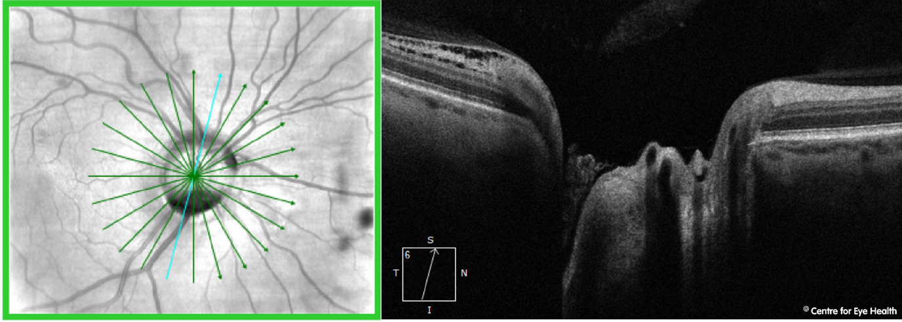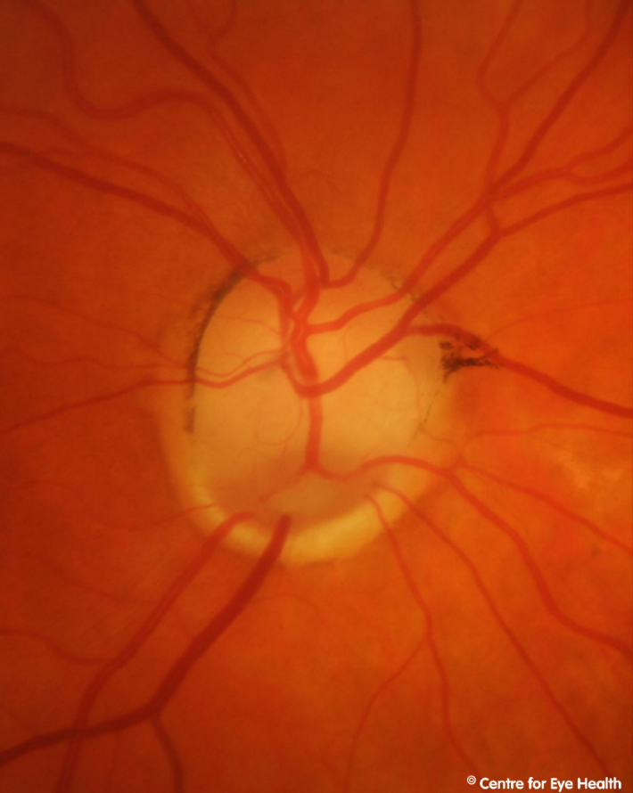





**Answer**

The right disc is irregular in shape and enlarged with a grey oval excavation noted at the inferior margin. There is a complete absence of neuro-retinal rim inferonasally and OCT imaging through the disc shows a deep cavity inferiorly. A peripapillary retinoschisis can also be seen inferiorly.

These findings are consistent with a diagnosis of optic disc coloboma. This is a congenital condition which may be inherited (autosomal dominant or autosomal recessive) or may be an isolated anomaly.

Colobomas form due to the incomplete closure of the embryonic fissure during foetal development. They are typically found inferonasally and there may be an associated field defect. Colobomas may occur in the retina/choroid, optic nerve, iris, or in combination, so a thorough ocular examination should be conducted to rule out involvement in other locations. In this case the coloboma was limited to the optic disc.